**Step-01: unzip -> WP4HUBT.zip file**

**Step-02: open with VScode**

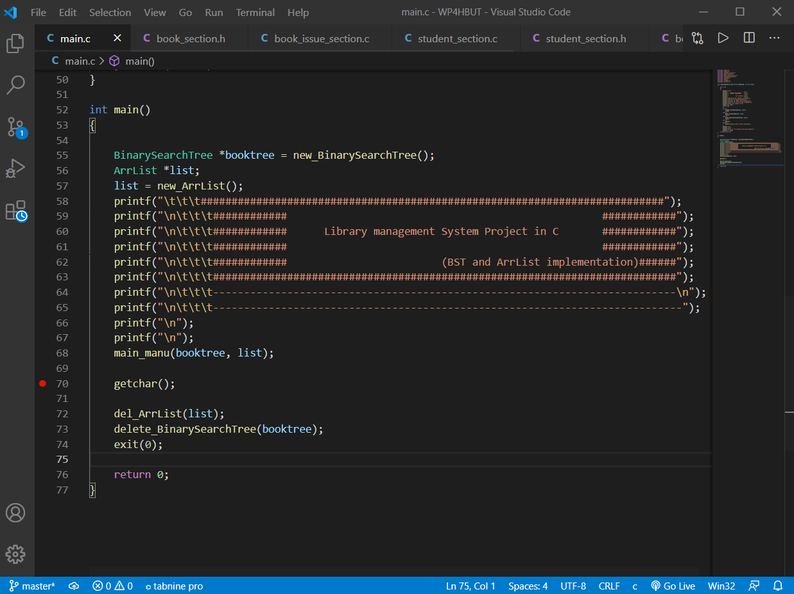

**Stop-03: open VScode terminal**

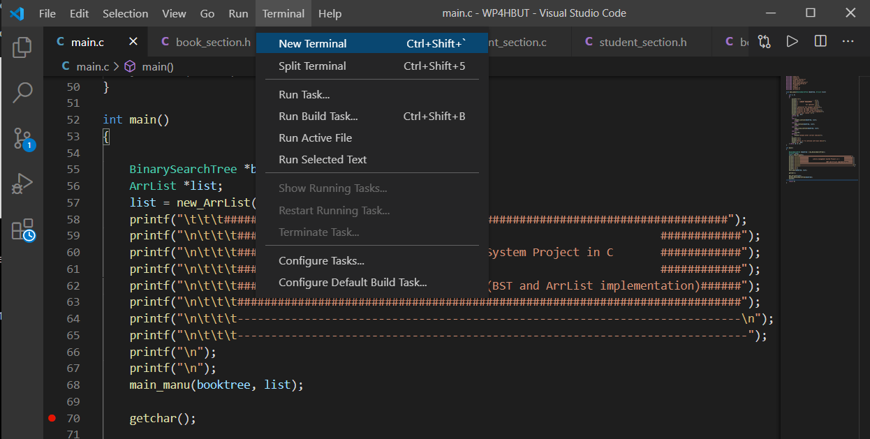

**Stop -04:** main.c –o test BinaryTree.c BinarySearchTree.c ArrList.c book_section.c student_section.c book_issue_section.c

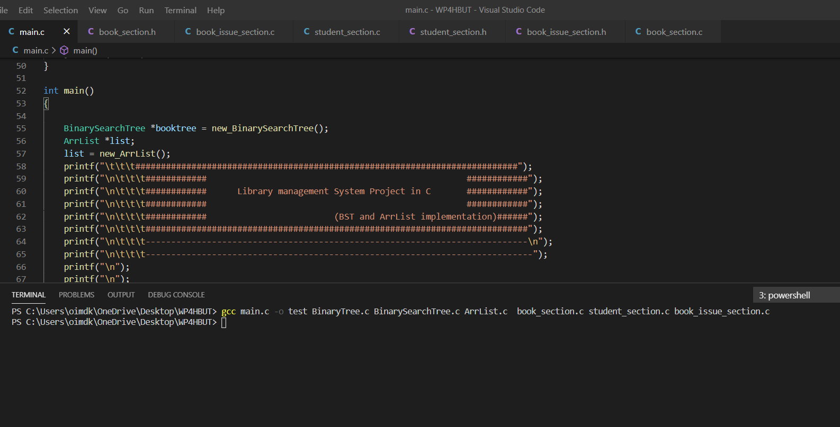

**Stop -05:** ./test.exe

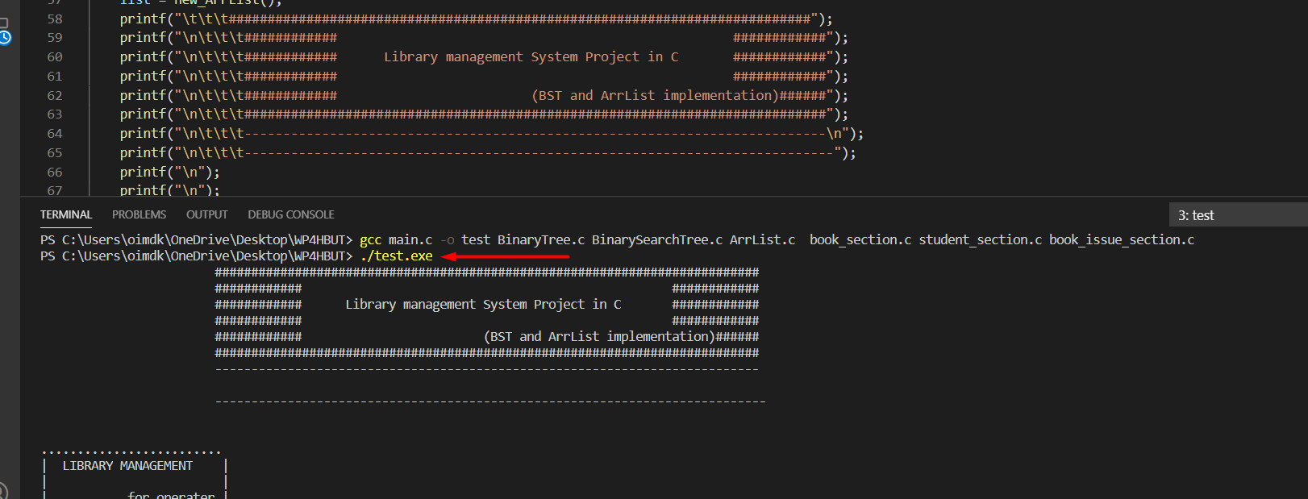

**Step-06:** use to user’s guide for operate this software